51st Annual WESTOP Meeting, October 13-15, 2023

Saturday Seminar Topic:
The Jaws are Really, REALLY Different
Jerry E. Bouquot, DDS, MSD, DABOMP, DABOM (Hon)

Director of Research, The Maxillofacial Center for Education and Research, Morgantown, West Virginia
Emeritus Professor & Past Chair, Department of Diagnostic & Biomedical Sciences, University of Texas
School of Dentistry, Houston, Texas
Clinical Professor & Past Chair, Division of Oral & Maxillofacial Pathology, Department of Diagnostic
Sciences, School of Dentistry, West Virginia University, Morgantown, West Virginia

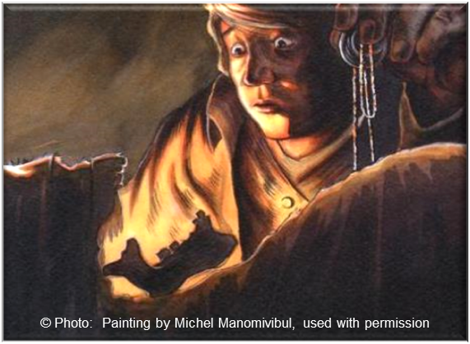
This seminar will discuss the 18 ways that jawbones differ significantly from all other bones in the human skeleton. It will specifically discuss the impact this has on jaw diseases and will be given by the only dentist, worldwide, who has had a Bone Pathology Fellowship (Mayo Clinic, Rochester, Minnesota), spending an entire year working with neoplasms and other pathoses of extragnathic bones. He has continued this interest for his entire career, including several decades of teaching bone pathology to orthopedic surgeons, and publishing dozens of papers and book chapters on the topic.

Participants will receive a copy of the presentation, as well as a Power Point modules with more than 700 “virtual” oral pathology cases original to Dr. Bouquot and his main mentor, Dr. Robert Gorlin, from the University of Minnesota.

Note: Alternate photo on following page:
